**AIRA ELEONA DEL ROSARIO**

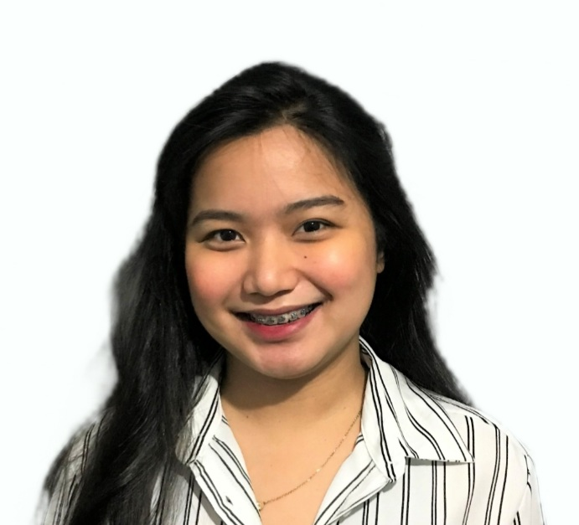

70 D E- Mendoza St. Buting, Pasig City

Cell #: 09551975517

E-mail: eleonaira2222@gmail.com

**WORK EXPERIENCE**

**1. COMPANY NAME : Centratel Outsourcing**

**POSITION TITLE** : Outbound Sales Representative

**ADDRESS** : Julia Vargas, Ortigas. Pasig City

**INDUSTRY** : Business Processing Outsourcing (Appointment Setting)

**YEAR JOINED** :March 2016 - January 15, 2017

**2. COMPANY NAME : Teleperformance**

**POSITION TITLE** : Customer Service Representative

**ADDRESS :** Ayala ave., cor Sen. Gil puyat Avenue, Makati City

**INDUSTRY :** Business Processing Outsourcing (Customer Service)

**YEAR JOINED** :January 23, 2017 – October 2, 2017

**3. COMPANY NAME : IQVIA**

**POSITION TITLE** : Technical System Support Analyst

**ADDRESS :** The 30th Corporate Center, Meralco Ave., San Antonio Pasig City, Philippines 1604

**INDUSTRY :** Back Office - Healthcare/Technical Support

**YEAR JOINED** :August 16, 2018 – Present

**PERSONAL INFORMATION**

**AGE:** 26 years old **BIRTH DATE:** December 22,1996

**NATIONALITY:** Filipino **GENDER:** Female

**CIVIL STATUS:** Single

**EDUCATIONAL BACKGROUND**

**TERTIARY**: **Rizal Technological University**

Bachelor of Secondary Education major in Computer

Boni Campus, Mandaluyong City

3rd year (Undergraduate)

**SECONDARY**: **San Joaquin-Kalawaan High School**

San Joaquin, Pasig city

2009-2013

**PRIMARY**: **Buting Elementary School**

Buting, Pasig City

2003-2009

**ADDITIONAL INFO**

**Career Objectives:** To develop my skills, knowledge, and challenges in practising what I have learned and to be a part of a growing company.

**CHARACTER REFERENCES**

**Mr. Ronald Rabino**

Colleague

IQVIA

09158005288

**Ms. Crevelyn Beltran**

Colleague

IQVIA

09755581491

**Ms. Katherine Balili**

Colleague

IQVIA

09777533950

I hereby certify that the above information is true and correct to the best of my knowledge.



**Aira Eleona Del Rosario**

Applicant’s Signature