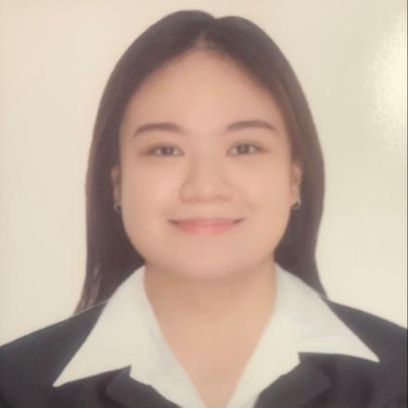**Allison Suade Z. Moya**

Block 16 Lot 4 Greenside Homes Malagasang II-D

Imus, Cavite, PH

+63 956 148 6310

Email: [allisonsuade28@gmail.com](mailto:allisonsuade28@gmail.com)

**Objective**: To secure a challenging position in a reputable organization to expand my learning, knowledge and skills, while making a significant contribution to the success and growth of the company.

**Work Experience:**

May 2021 - Present INETCOM GLOBAL (Outbound Sales Representative)

**Educational Background:**

College: Emilio Aguinaldo College Cavite

Bachelor of Science in Psychology S.Y. 2016-2020

De La Salle Medical and Health Sciences Institute

Bachelor of Science in Medical Laboratory Science S.Y. 2015-2016

High School: Maranatha Christian Academy S.Y. 2011-2015

Elementary: Maranatha Christian Academy S.Y. 2005-2011

**Skills:**

* Customer Service Orientation
* Computer Literate
* Attention to details
* Multi tasking
* Time Management
* Excellent Interpersonal Skills

**Character References:**

Kevic Balan

IT Engineer

Huawei Technologies Inc. Phils

+63 977 701 4827

Sweden Cortez

Barista

Starbucks, PH

+63 916 395 0201

Susan Go

Assistant Security Officer

PAGCOR PH

+63 905 354 9412