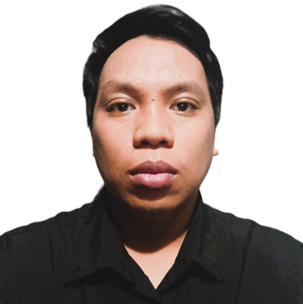

**August Ray-van Lagwa-an**

**https://www.linkedin.com/in/august-ray-van-lagwa-an-4a9422207/**

[rvlagwaan@gmail.com](mailto:rvlagwaan@gmail.com)

09212032492

SUMMARY

* 5 years’ total work experience Customer Service Associate and Data Analyst in 3 separate well established companies. Teleperformance, Accenture and With. Intelligence.
* Quality Assurance in current company (With. Intelligence) operating mainly in UK. Quality Checking for 2 and half years.

PROFESSIONAL EXPERIENCE

With. Intelligence   
Quality Analyst and Training (Cebu) (May 2021 until current date)

* One of 10 Quality Analyst reporting in Cebu office
* Quality Checking of researcher’s (Data Analyst) research build/task and handling new hires in Nesting stage.
* Conduct a refresher training for researchers every quarter in a year.

Teleperformance  
Customer Service Representative (Globe Telco Account)   
(October 2016 – June 2017)

* Assisting customer’s issue through call and providing the most suitable solution for customer’s issue and pitch in some products for sales.

Performance360

Outsourced Claims Support in Trax Technologies.   
(February 2019 – February 2020)

* Request claims of unsuccessful delivery of parcels for both (FedEx and United Parcel Service (UPS))
* Assign Team Lead for the whole duration of being in Outsourced by Trax Technologies.

Accenture  
Customer Service Associate (Virgin Mobile Telco Account)  
(May 2020 – August 2020)

* Assisting customer’s issue through call and providing the most suitable solution for customer’s issue and pitch in some products for sales.

Educational Background  
College Level:

* Bachelor of information Science Information Technology (Undergrad).

SKILLS

Skills acquired throughout the years

 MS tools | Photoshop | Video editing | Adobe Tools | 3D tool - Blender