**Clarence D. Jereza**

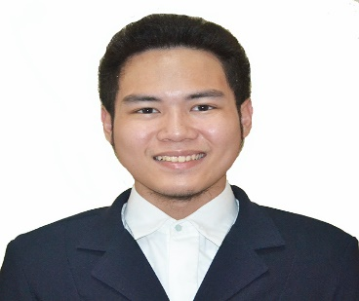

**Address:**

Dona Juliana, Las Palmas, Los Angeles St.

Bacolod City, Negros Occidental, Philippines 6100

­­­

**Mobile :** +639178021091 / 034-434-4509

**E-mail :** jerezaclarence@Yahoo.com

**OBJECTIVE**

*Seeking a job position with a company where I can utilize my potential and capabilities to achieve the organizational objectives and seize the opportunities for professional development. Seek to work in an environment that will challenge me further while allowing me to contribute to the continued growth and success of the organization.*

**PERSONAL DATA**

**Date of Birth :** May 6, 1997

**Place of Birth :** Bacolod City, Philippines

**Age :** 25

**Gender :** Male

**Nationality :** Filipino

**Civil Status :** Single

**Religion :** Roman Catholic

**Height :** 5’7

**Weight :** 165 lbs

­­­

**ACADEMIC BACKGROUND**

Tertiary: University of St. La Salle - Bacolod City

Bachelor of Science in Business Administration Major in Operations Management and Business Economics

2018

Secondary: University of St. La Salle – Bacolod City

2014

Elementary: University of St. La Salle – Bacolod City

2010

**QUALIFICATIONS**

*Excellent decision maker, good English writing and verbal communication skills, Proficient with the English Language, computer literate, hardworking, able to handle pressure, able to manage time.*

**SEMINARS and WORKSHOPS**

**Forex: Learn To Trade**

L’ Fisher Hotel, Bacolod City, September 2016

Greg Secker

**Logistics: In The Midst Of Globalization**

Benjamin Hall, Bacolod City, October 2016

**Young Economist Convention 2016**

University of San Carlos, December 2016

**The Economics of the Environment**

University of St. La Salle, Bacolod City, January 2017

Atty. Wilmon Penalosa

**Young Economist Convention 2017**

University of San Carlos, December 2017

**CAMPUS AND COMMUNITY INVOLVEMENT**

* Member of the Production Support Group
* Decision Making Incorporated Member
* Junior Philippine Economics Society Member
* KA-UBAY Club Member

**PROFESSIONAL EXPERIENCES**

* CSR – Teller at Metropolitan Bank and Trust Company (April 2018 – April 2019)

**CHARACTER REFERENCES**

**Name with Title** Dante Gustilo

Position Professor

Company University of St. La Salle – Bacolod City

Contact Number +63 999 095 2962

**Name with Title** Ruby Belecina

Position Teacher

Company University of St. La Salle – Bacolod City

Contact Number +63 933 990 4381 / +63 929 481 3172

**Name with Title** Diana A. Peña

Position Chair, Business Economics Dept.

Company University of St. La Salle – Bacolod City

Contact Number +63 923 256 9004