**DANIEL ALFEREZ SALISI**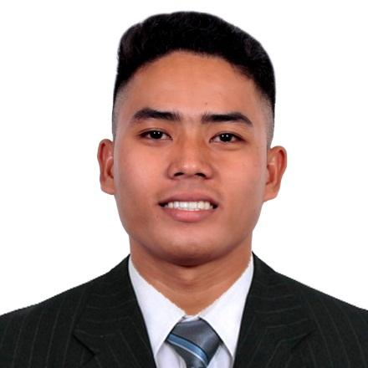

*Bachelor in Elementary Education-Graduate*

*Permanent Address: 294 Zone 2, Tapel, Oas, Albay (4505)*

*Present Address: Sta. Cruz, Naga City, Camarines Sur (4400)*

*Contact No.: 09910087966 / 09152603704*

*Email Address:* [*danielsalisi1029@gmail.com*](mailto:danielsalisi1029@gmail.com)



**I. CAREER OBJECTIVE:**

Seeking a challenging opportunity where I will be able to utilize my organizational skills, educational backgrounds, and ability to work well with people or in a team which will allow me to grow personally and professionally while making a significant contribution to the success of the company.

**II. PERSONAL DATA:**

Date of Birth: October 29. 1997

Place of Birth: Tapel, Oas, Albay

Sex: Male

Age: 25

Civil Status: Single

Religion: Born Again Christian

Height: 5’7

Weight: 69kg.

Father: Vicente P. Salisi

Mother: Marry Ann A. Salisi

**III. EDUCATIONAL ATTAINMENT:**

* Tertiary : Oas Community College – Calzada, Oas, Albay (2015-2019)

Academic Awardee (1st - 3rd yr.)

* Secondary : Grace Christian Mission Technical School – Badian, Oas, Albay (2011-2015)

10th Honorable Mention

* Primary : Tapel Elementary School – Tapel, Oas, Albay (2005-2011)

1st Honorable Mention

**IV. KEY SKILLS/ WORK EXPERIENCE / AWARDS & RECOGNITIONS:**

* Completed 480 Hours of Student-Teaching Training (November-March 2019)
* Completed NSTP-CWTS Training (2015-2016)
* Science Club Organization Business Mngr. (2017-2018)
* Can work independently or as a part of a team
* Received Certificate of Recognition as one of the Top Sales Performers of 2020 and 2023
* Licensed Professional Teacher (2019-Present)
* Worked as a Customer Service Sales Representative in Sutherland Global Services (November 11, 2019 – August 7, 2023)

**V. CHARACTER REFERENCE:**

AIMEE HAMOR ANCHINGES

09955771995