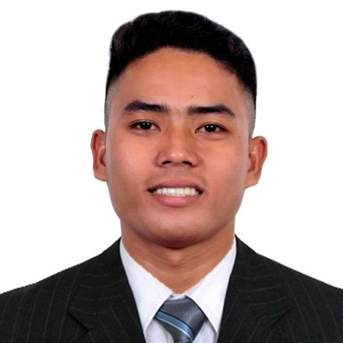
DANIEL ALFEREZ SALISI
Bachelor in Elementary Education-Graduate
Permanent Address: 294 Zone 2, Tapel, Oas, Albay (4505)
Present Address: Sta. Cruz, Naga City, Camarines Sur (4400)
Contact No.: 09910087966 / 09152603704
Email Address: danielsalisi1029@gmail.com

I. CAREER OBJECTIVE:

Seeking a challenging opportunity where I will be able to utilize my organizational skills, educational backgrounds, and ability to work well with people or in a team which will allow me to grow personally and professionally while making a significant contribution to the success of the company.

II. PERSONAL DATA:
Date of Birth: October 29. 1997
Place of Birth: Tapel, Oas, Albay
Sex: Male
Age: 25
Civil Status: Single
Religion: Born Again Christian
Height: 5’7
Weight: 69kg.
Father: Vicente P. Salisi
Mother: Marry Ann A. Salisi

III. EDUCATIONAL ATTAINMENT:

- Tertiary : Oas Community College – Calzada, Oas, Albay (2015-2019)
Academic Awardee (1st - 3rd yr.)

- Secondary : Grace Christian Mission Technical School – Badian, Oas, Albay (2011-2015)
10th Honorable Mention

- Primary : Tapel Elementary School – Tapel, Oas, Albay (2005-2011)
1st Honorable Mention
IV. KEY SKILLS/ WORK EXPERIENCE / AWARDS & RECOGNITIONS:

- Completed 480 Hours of Student-Teaching Training (November-March 2019)
- Completed NSTP-CWTS Training (2015-2016)
- Science Club Organization Business Mngr. (2017-2018)
- Can work independently or as a part of a team
- Received Certificate of Recognition as one of the Top Sales Performers of 2020 and 2023
- Licensed Professional Teacher (2019-Present)
- Worked as a Customer Service Sales Representative in Sutherland Global Services (November 11, 2019 – August 7, 2023)
V. CHARACTER REFERENCE:
AIMEE HAMOR ANCHINGES
09955771995

