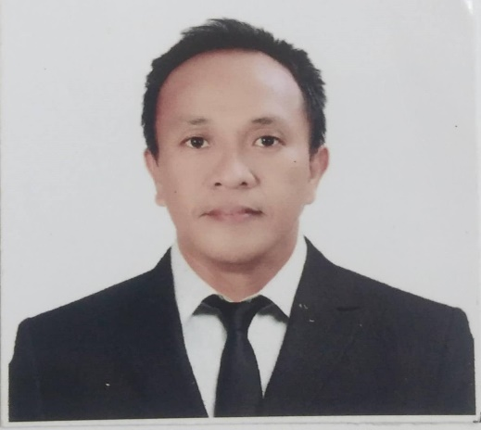

DENNIS ADANZA ANDOY
Mobile Number: +639319202514
Email Address: dennisandoy2020@gmail.com
Present Address: Esperanza Homes,
Barangay Can-Asujan, Carcar City, Cebu 6019

PROFILE:
A hardworking candidate who is receptive to learning and passionate to explore opportunities to grow professionally and personally. Bringing forth several years of experience in different fields of work that shows reliability, determination and flexibility. Equipped with promising skill set conducive to creating positive team relationships.

EMPLOYMENT HISTORY:
- ASSOCIATE in Wipro Philippines Inc., Cebu City -April 12, 2021 up to PRESENT:

- Support process by managing transactions as per required quality standards:
-Identify red flags in social media platform specifically Facebook and accurately troubleshoot following the given standard processes and procedures.
- Build capability to ensure operational excellence:
-Consistent updates on job knowledge through weekly Refresher courses and quarterly Knowledge Check courses.
-Partner with Team Leader and Quality Assistant to brainstorm and identify training themes and learning issues inorderto ensure compliance in product specific requirements and recommendations.

- PROBATIONARY EMPLOYEE, Customer Service Representative in
Sykes Asia, Inc. Cebu City March 9, 2020- November 19, 2020

- Providing product support and resolution to clients by performing a question diagnosis while guiding users through step-by-step solutions.

- PRODUCTION WORKER, Litecrete Corp. Mandaue City, Cebu -August 10, 2018- September 14, 2019

- Machine operation in filing of finished hollow blocks
- Assisting in the hollow block making process

- TEACHER in Elementary -June 2001 up to May 16, 2018 Cotabato City, Maguindanao

St. Benedict College (Homeschool): Private June 2001- 2003
Sero Central School: Public
Substitute Teacher June 16, 2003- August 8, 2003
Regular(Permanent) September 15, 2006- September 14, 2009
Cotabato City Central pilot School: Public
September 15, 2009- April 17, 2018

- Taught Music, Arts, Physical Education and Health (MAPEH)
- Sepak Takraw coach
- Drum and Lyre coordinator

EDUCATION:
Notre Dame University- Bachelors of Science in Elementary Education
College Graduate 1997-2001
SKILLS:
- Basic Computer operation
- Efficient Time management
- Strong Work Ethics
- Good Teamwork and Collaboration
- Team Leadership skills

REFERRENCE:

- Mr. Ricky Gumban
PASTOR, Faith Tabernacle Church
Ibabao-Estancia Mandaue City, Cebu 6014
+639269143207

- Mr. Rogelio Cainela
PASTOR, Cebu Jesus First Gospel Ministry
Carcar City, Cebu
Esperanza Homes, Barangay Can-Asujan, Carcar City, Cebu 6019
+639754178320

- Human Resource Department, Wipro Philippines Inc.
Cebu IT Tower Block 2, corner Archbishop Reyes and Mindanao Streets, Cebu Business Park, Cebu City 6000
+63-32-230-1000

- Mr. Shaffa Guiani
PRINCIPAL IV, Cotabato City Central Pilot School
Sinsuat Avenue, Cotabato City 9600
(064)421-8005

- Mr. Lyle Harvey Arceo
Former Employee, Wipro Philippines Inc.
Paknaan, Mandaue City, Cebu 6014
09091755082

- Mr. Rene Alain Awiten
Former Employee, Sykes Asia Inc. Cebu City
E-mail address: renealain.awiten@sykes.com

