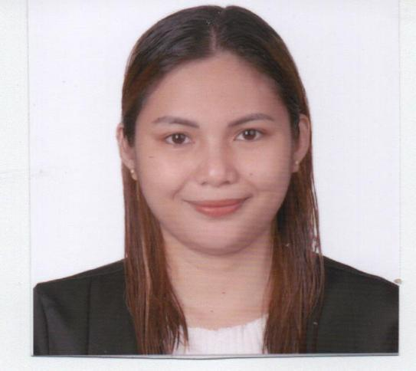

**FLOREMIE L. FLORIDA**

Purok Santol Barangay Santo Niño

Panabo City, 8105

+639456624780

floridalfloremie1120@gmail.com.

**CAREER OBJECTIVE**

* Learn and to be flexible in any field of Finance to develop my skills and potential.
* To secure a challenging position in a reputable organization to expand my learnings,

knowledge, and skills.

* Seeking an entry-level position to begin my career in a high-level professional environment.

**PERSONAL INFORMATION:**

**______________________________________________________________**

Birth date : November 20, 1995

Age : 27

Birthplace : Panabo, Davao

Height : 5 feet 3 inches

Weight : 64 kilograms

Status : Single

Religion : Roman Catholic

Citizenship : Filipino

Language/Dialect Spoken : English,Filipino,Cebuano,

**EDUCATIONAL ATTAINMENT:**

**Tertiary Level** Bachelor of Business Administration Major in

Financial Management

UM Panabo College, Arguelles St., Panabo City

(SY 2021-2022)

**Vocational** RTC-KPVTC Tesda

Food Processing and Housekeeping NCII

Tesda Tibungco, Davao

(2014-2015)

**Secondary Level** Panabo National High School

Northern Plain, Panabo City

(SY 2015-2016)

**PRE-PROFESSIONAL WORK EXPERIENCE­­**

* **On the-Job Training ( OJT )**

RTG Accounting Firm

March –April 2022

**WORK EXPERIENCE**

* **Field Enumerator**

City Planning Office

LGU Panabo City Government

December 2020- March 2021

* **Accounting staff- Billing**

Fast logistics corporation

Sasa Davao City

January 3,2023- May 15, 2023

**KNOWLEDGE AND SKILLS**

* Computer Literate (MS Word, Excel, and PowerPoint)
* Can work less Supervision
* Knows how to manage time wisely
* Can work under pressure
* Goal-Oriented and task Motivated
* Can work professionally with different people in the organization

**SEMINARS/ TRAINING PROGRAMS ATTENDED**

* **JCFAP Davao Chapter Financial Literacy Caravan Seminar:**

Investment Awareness through Financial Campaign

SMX convention Lanang Davao City.

November 9, 2019

* **Financial Literacy Webinar**

Economic Planning For Young Earners

UM Panabo College

May 22, 2021

* **Leadership Webinar**

Living Limitless: Leadership and Academic Excellence amidst Challenges

Office Students Affair- UM Main Campus

November 24, 2021

* **Bangko Sentral Ng Pilipinas**

Economic and Financial Learning Program (Session for Students)

September 21, 2021

* **Customer service vs. Customer delight: The banking Industry Practices**

Webinar Series for Financial Management Students

March 07, 2022- May 13, 2022

* **The Role of Technology in Banking: The New Normal Setting**

Webinar Series for Financial Management Students

March 07, 2022- May 13, 2022

**AFFILIATIONS**

* **Junior Financial Executives UMPC Chapter**

UM Panabo College

President

2021-2022

* **College Student Office**

UM Panabo College

Vice-president External

2020-2021

* **Honor Society**

UM Panabo College

President

2021-2022

* **Department of Student Government**

UM Panabo College

Vice-Governor

2019-2022

* **Junior Confederation of Finance Associations- Philippines**

**Davao City (JCFAP)**

Vice-President For Communication and Promotions

2018-2021

**CHARACTER REFERENCES**

**ANTONIETTA T. OCAY, DBA**

Program Head BSBA- FM

UM Panabo College

0917-719-1109

**MARY ANGELA L. RODRIGO**

Professor

UM Panabo College

0906-378-9022

**NARMELA POSPOS**

District Supervisor

Schools Division Superintendent

Davao City

I hereby certify that the data above are true and correct.



**FLOREMIE L. FLORIDA**