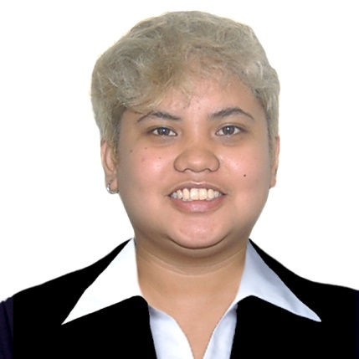

**Aquiatan, Inah Joyce V.**

Address: Sec 2 Blk 4 Lot 29, Sunny Brooke II

Barangay San Francisco, General Trias, Cavite

E-mail: aquiatanpotpot@gmail.com

WMobile Number: +63 9309200477

**Objectives:**

* To be part of the company where I can fully utilize my skills and enhance my potentials.

**Personal Qualifications:**

* Cooperative, fast learner, willing to learn new things beyond my profession, Flexible, Hardworking and Motivated Person. I’m also willing to share my skills and knowledge to the fullest extent that I can give. I can work with minimum supervision.

**Personal Background:**

Age : 24 Yrs. Old

Gender : Female Birthdate : January 25,1999

Language : English, Filipino Weight : 70 Kg

Marital Status : Single Height : 163 cm

**Educational Attainment:**

SECONDARY (Graduated)

Senior High School

Asian Institute of Science and Technology

AISAT Building, Emilio Aguinaldo Hwy, Dasmarinas Cavite

Junior High School

Governor Ferrer Memorial National High School San Francisco Annex

Barangay San Francisco, General Trias Cavite

PRIMARY (Graduated)

Sunny Brooke Elementary School

Barangay San Francisco, General Trias Cavite

**Special Skills:**

* Customer Service Assistance
* Marketing Skills (Sales)
* Computer Literate
* Proficient on Microsoft Word and Excel
* Serving Customer/ Cleaning Background
* Can speak English fluently

**Work Experience:**

IQOR Philippines

• **Customer Service Representative**

*April 2019 – February 2021*

Teleperformance

• **Customer Service Representative**

*August 2021 – August 2022*

IQOR Philippines

• **Customer Service Representative**

*August 2022– December 2022*

IGT SOLUTIONS

* **Customer Service Representative**

February 2023- July 2023

**References**:

1. Name : Vesta Amor A. Duque

Relationship : Friend

Position : Customer Care Specialist

Company : Ocwen Business Solutions

Mobile Number : +639309200477

1. Name : Jearamee Sarion

Relationship : Former Supervisor

Position : Customer Care Quality Manager

Company : IQOR Philippines

Mobile Number : +63 9470111551

1. Name : Radley Nicomedes

Relationship : Friend

Position : Customer Experience Associate I

Company : HGS

Mobile Number : +63 9954369388

**AQUIATAN, INAH JOYCE V.**

*Applicant*,