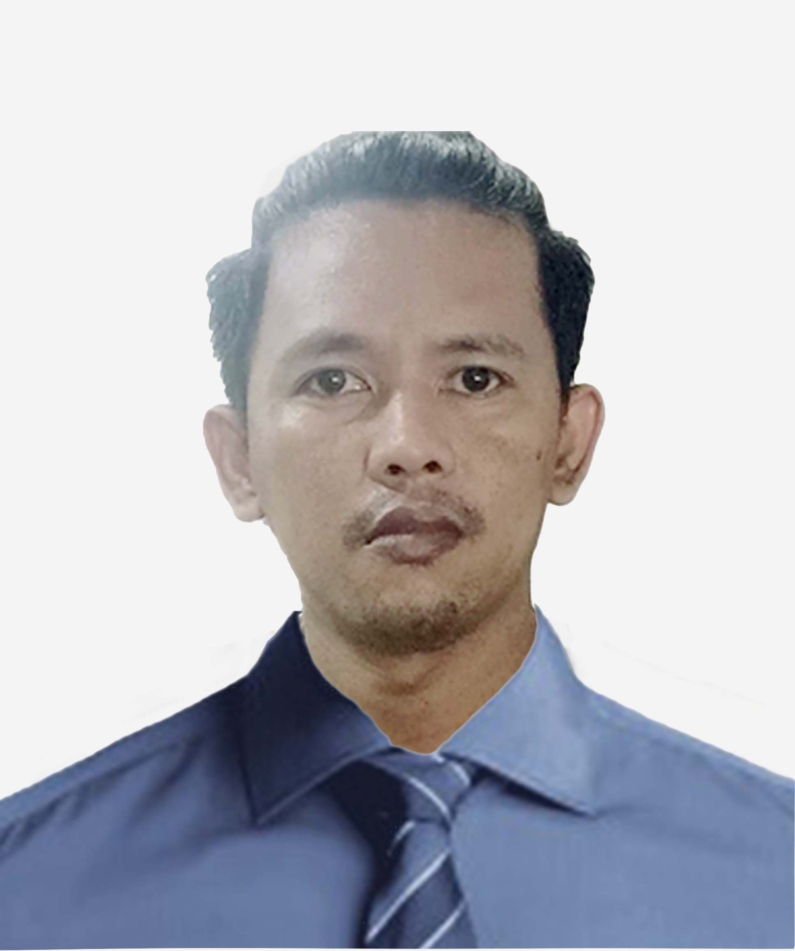 |  |  |  | Jessie Joel L. Arac

Objective

To have a job that would enable me to use my talent and skills as well as contribute to organization’s goals and which would provide excellent opportunities for career advancement and personal growth.

Experience

June 2022 – June 2024

- Ava Billing AR Representative
- Check and track claims status.
- Call Payors, utilize payer portal and all other resources available to ensure resolution of outstanding claims balances.
- Update information in practice management software to ensure timely resolution of outstanding AR.

April 2021 – May 2022

- Garrett and Talon Inc. CSR Representative

- Respond to costumers on the phone and by email.
- Gather costumer information, access and fulfill customer needs.
- Troubleshoot costumer’s issues over the phone.

2018 – 2020

- FBCRS Consumer Research Field Interviewer

- Conduct interviews to collect accurate data
- Collecting data from field surveys and verification of the data
- Conducting extensive and thorough visual surveys of areas covered during the census procedure

Education
Informatics College of Manila 2015 - 2016
Bachelor of Science and Information Technology (B.S.I.T)
BDO Building, 2070 Recto Ave, Quiapo, Sta. Cruz Manila

NHC High School 1998 - 2002
NHC Village, Tala, Barangay 186
Caloocan City, Metro Manila

Qualification
• Computer Literate.
• Competent and diligent in the area of chosen field.
• Can get along with peers and superiors in the working area.
• Open-minded and has leadership skills.
• A pro-active person, innovate and has keen interest in learning
more new challenging working environment.

References
- Nesty Tablizo
Commission on Audit – Office Staff
Diliman, Quezon City

- Mark Celis Agustin
Mass Rapid Transit - Supervisor
Manila Station
Blk 5 Lot 17 Maginoo St. Graceville III Subdivision,
City of San Jose Del Monte, Bulacan
3023
 |  | 63 993 486 4706
 |  | aracjessiejoel@gmail.com

