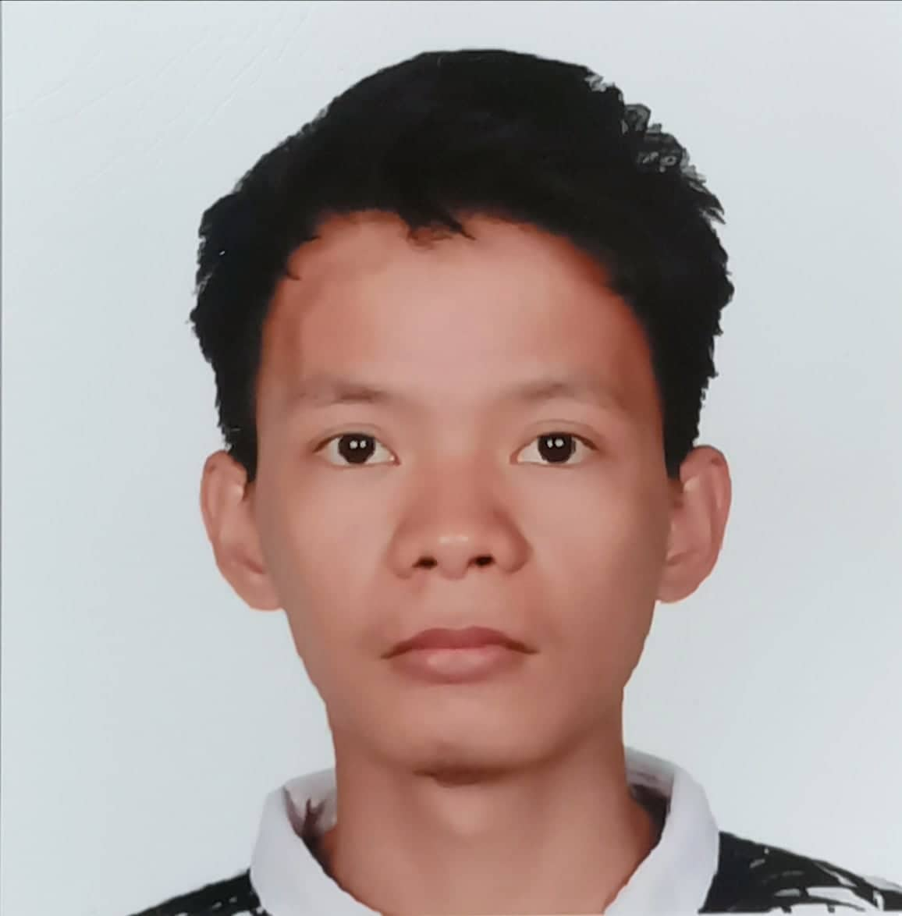 |  | SKILLS
John Paul paulino  Profile  To be able to work in an institution where I use my skills and knowledge to deliver value added results as well as to enhance my learning eager to get opportunities to improve myself professionally and contribute to the growth of the customer to achieve its goal.  CONTACT  PHONE:  +639353477974/+639706230261  LINKEDIN:  https://www.linkedin.com/in/john-paul-p-5a108525a/  EMAIL  Paulinojohnpaul19@gmail.com |  | WORK EXPERIENCE

JOB ORDER

DEPARTMENT OF LABOR AND EMPLOYMENT

JANUARY 2021- SEPTEMBER 2021
Responsible for interviewing beneficiaries and encoding of their personal data in DOLE system. Assist them of their complains. Making PowerPoint presentation for our Focal persons. Over 8 months of service as a Job order I made 5 presentations, and encoded 73% of 3500 beneficiaries in 12 projects of DOLE.

DIgital imaging specialist

iron mountain

April 2022 – July 2022
Involve in indexing to manually encode the missing data of BDO Clients. Scanned and Quality control to maintain a quality of the images. Top trainee of our batch and have the highest encoded data’s client.

Claims processor

eiti
August 2022- November 2022
In charge of processing the bills Maxicare Clients’ HMO. Obtain and verify information, correspond with providers and beneficiaries, and process claim payments. Always got our quota and processed the hard bills of our group.
 |  | EDUCATION

bachelor of secondary education major in mathematics

osmeÑa colleges
2016-2020

