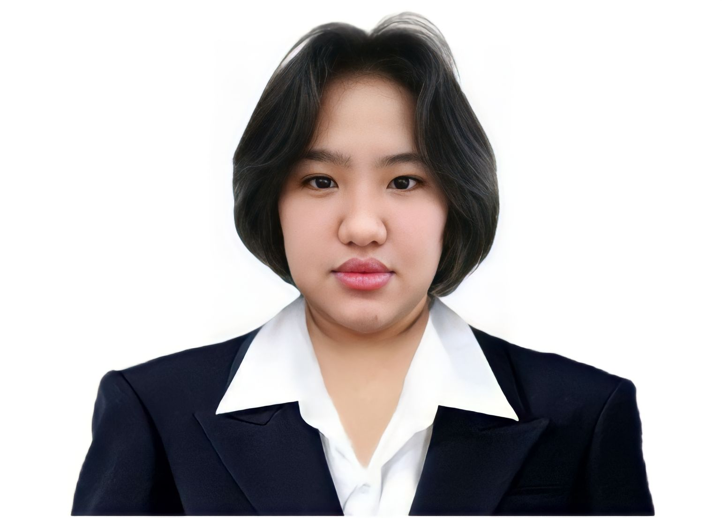 |  | Jorene G. TANGO
Profile  Graduate of ABFilipinology in PUP with a major in Language and Literature I am a flexible and experienced customer service representative with excellent time management skills. I am a good communicator with proven interpersonal skills and am used to working in a team while also being capable of using my own initiative. I am skilled at dealing with problems in a resourceful manner and negotiating to achieve a beneficial agreement. I am always enthusiastic to learn and undertake new challenges.  Contact on  ADDRESS:  #8 Sta. Brigida Karuhatan, Valenzuela  PHONE:  09951831946  EMAIL:  jorenetango08@gmail.com  Hobbies  Writing Stories  Reading articles  Watching Documentaries  Computer exploring  Communicating with other  Acting  Dance  Sing  Playing instruments |  | EDUCATION  [Polytechnic University of the Philippines]  [2014 – 2018]  AB Filipinolgy, major in Language and Literature  [Sergio Osmeña Sr. High School]  2010 - 2014  [Cabaritan West Elementary School]  2004-2010  WORK EXPERIENCE  [Hataw! D’yaryo ng Bayan – News Writer trainee  April – May 2016  Gathering story reports from different Precinct and compiling it to make a story, proofreading ang researching. Contributed a story in their official tabloid.  [PUP Senior High School] – Student Teacher  April – May 2017  Teaching 4 sections of senior high, making lesson plans and creating a visual aids for teaching and helping Critique Teacher in computing grades  [iFm 93.9] – Production intern  May – June 2018  Assisting the DJ’s in the studio and writing scripts for their programs.  [Transprint corp.] - Project coordinator  October 2018 - Feb 2019  Coordinating with sales production to proceed the project incoming.  [Asylum] - Actor/receptionist  June 2019 - Feb 2020  Scare actor and at same time receptionist because of the briefing and reminders for the safety of the customer  [Concentrix] - Customer Service Representative  August 17 - November 25  Serves customers by providing product and service information and resolving product and service problems.  [Alorica] - Customer Service Representative  May - September 2021  Providing the best product and service information and resolving product and service problems.  [Concentrix] - Customer Service Representative  September 2022 - March 2024  Serves customers by providing product and service information and resolving product and service problems. Handled a healthcare account for both provider and member line.  [Booth and Partners] - Customer Success Specialist  April 2024 - Present  Satisfying and ensuring that every customer interaction is characterized by clarity, empathy, and expertise. Their goal is not only to meet but exceed customer expectations by resolving their queries, concerns, and issues on the very first call while working with our provider network to solve all customer requests/issues.  SKILLS

