 | 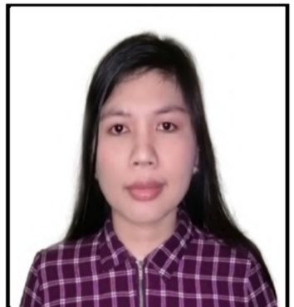

josephine gongob

COMMERCE GRADUATE

CONTACT   0953-236-8925   joyjavellana462@gmail.com  Canelar Moret, Zambo. City  PERSONAL DATA  Name: Josephine Javellana Gongob  Birth date : August 31, 1986  Birth place : Langon, Zamboanga Sibugay  Age: 35  Height: 5’0’’  Religion: Alliance  Sex: Female  Civil Status: Single  Language: Visayan, Tagalog and English |  |  | PROFILE  I have twelve years of work experience in various businesses, such as: mining companies (ore and coal), power distribution (electricity), new account savings officer in a rural bank, and secretary in a real estate company.  Based on these experiences, I have developed an efficient skill to manage the pressure on a given task and deal with deadlines. I also gained the capability to think in a strategic and analytical manner.  Furthermore, I am self-motivated, hard-working, open-minded and have a strong work ethic. I'm a good listener and a fast learner.
skillS  ♦Computer literate  (Microsoft word, excel  and power point)  Lay outing and others  ♦Good in communication  verbal and written  ♦Good in noticing technical errors  ♦Good in numeracy  ♦ Documentation  EDUCATION  Elementary  1994— 2000— Ipil Central Elementary School  Secondary  2000– 2004— Dr. Aurelio Mendoza Memorial Colleges  Tertiary  2004—2008— Dr. Aurelio Mendoza Memorial Colleges  Bachelor of Science in Commerce major in Management  ACHIEVEMENTS  Auditor - Supreme Student Council  (Fourth year College) at Dr. Aurelio Mendoza Memorial Colleges  Loyalty award - Dr. Aurelio Mendoza Memorial Colleges |  |  | EXPERIENCES  2021  MEKY ESTATE LESSOR (Building Rental) / J-JIREH ICE PLANT AND COLD STORAGE – (IcePlant)  Canelar, Zamboanga City  Position: Secretary  ♦Process / File and pay taxes online at Bureau of  Internal Revenue (BIR) - Monthly, Quarterly and  Annually  ♦ Monitor banking transactions (Bank  reconciliation)  ♦ Record daily sales and expenses  ♦ Accounting duties (Book keeping)  2016 – 2020  REPOWER ENERGY DEVELOPMENT CORPORATION  (Power distribution)  Valencia City, Bukidnon  Position: Administrative Staff  ♦Transact different government agencies  ♦Documentation  ♦Office / Accounting work  2016  KATIPUNAN BANK  (Rural Bank)  Tagoloan, Cagayan De Oro City  Position: New Savings Account Officer  ♦ Assist the client in opening an account  ♦ Record and keep the information of the client  ♦ Collect deposits of the client in their respective  establishments  ♦Handling petty cash funds for daily expenses  2010 – 2015  TITAN MINING ENERGY DEVELOPMENT CORPORATION  (Mining Company) - coal  Imelda, Zamboanga Sibugay  Position: Budget Controller  ♦Released money every week on field officials  ♦Record daily cash transactions  ♦Collect payments  2008 -2010  PACIFICO SUL MINERACAO CORPORATION  (Mining Company) -iron ore  Ipil, Zamboanga Sibugay  Position: Production Staff  ♦Record daily production  ♦Paper works  ♦O t h e r s
REFERENCES

Name: Malissa Facto Acasio
Contact #: 0953 -164 -0239
Address: Imelda, Zamboanga Sibugay

Name: Juanito B. Antonino
Contact #: 0917 -563 -4881
Address: San Miguel, Bulacan

