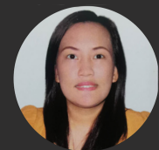**Jubilee L. Villaruel**

Monaco Street La Brezza Subdivision, Brgy. Pantoc

Meycuayan Bulacan Philippines.

Skype Id: +639531628657

Mobile #: +639087362924

**SUMMARY OF SKILL AND CAREER HIGHLIGHTS**

Customer Service Representative

Client coordinator

Appointment Scheduler

Sale Representative

**EDUCATIONAL ATTAINTMENT**

College:       Mount Carmel College

                     Undergraduate of BS Radiology Technology

**EMPLOYMENT HISTORY**

**TC Japan**

Sales representative

Philippines

August 2021 - January 2023

**The Doctor’s office**:

**Virtual Receptionist/Patient coordinator**

West Hollywood CA

January 2020- July 2021

**MDCS Dermatology Clinic:**

**Patient Coordinator**

[New York,](https://www.mdcsnyc.com/location/ny/new-york/midtown-east)

October 2018 - December 2019

**Souseiki Japan International**

**Customer Service Representative / Sales representative**

Cubao, Quezon City

Sept 2012 - July 2014