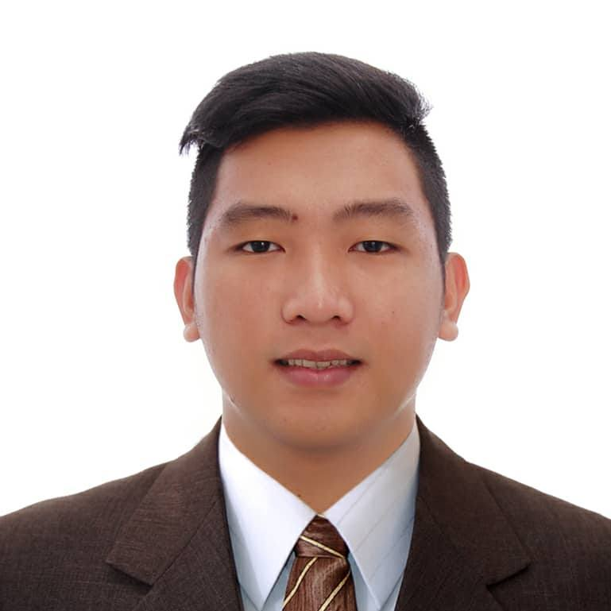

EDUCATIONAL BACKGROUND

TERTIARY:
Manuel S. Enverga University Foundation Inc.
Lucena, City Philippines
Bachelor of Science in Information Technology
2011 - 2015

SECONDARY:
Sacred Heart College
1 Merchan St. Lucena City
2007-2011

SKILLS

- Average user of Microsoft Office Application: Microsoft Office- MS Word, MS PowerPoint and MS Excel
- Troubleshoot Hardware and Software
- CCTV Installation
- Server Installation
- Knowledgeable in Cisco Routers Configuration
- Knowledgeable in Web Design, PHP and SQL Server
management studio.
- Configure Cisco Routers (VLAN, Access point, OSPF, BGP, EIGRP, Layer 3 Switching, IPv4 subnetting and addressing, Managing IP Configuration, Dynamic and Static Routing, Network Security, Spanning Tree EtherChannel)

Volunteer Works:

- Angels Walk for Autism

I hereby certify that the above information is true and correct to the best of my knowledge and belief.

Karlo Rei S. Lagdamen
Applicant

Karlo Rei S. Lagdamen
Fifth avenue place 5th Avenue corner, 21st Dr, Taguig, Metro Manila
Contact No.: 09851263356
Email Add: karlorei.lagdamen@gmail.com

CAREER OBJECTIVE

To utilize my skills and knowledge in the field of IT and harmonize with a team of experienced professionally.

SEMINARS AND TRAININGS ATTENDED
SAP Business One
Microsoft Technology Associate: Networking Fundamentals
Microsoft Certified Professional
CCNA 200-301: Implementing and Administering Cisco Solution
Social Media Management
Data Entry
Canva
Facebook ads
Lead Generation

PERSONAL INFORMATIONS

Age : 28
Date of Birth : July 24, 1995
Citizenship : Filipino
Civil Status : Single
Language Spoken : : English and Filipino
Parents : Reyndaldo S. Lagdamen and Nedy S. Lagdamen

WORK EXPERIENCE

Premiere BPO
MDM Support Engineer
Eastwood, Quezon City
January 2023 – Present

Atos
1st line support analyst/Service desk Analyst
McKinley Hill, Taguig City
September 26, 2022 – January 20, 2023

IBM Philippines INC.
P2P Helpdesk (Google Account)
Block 15, 3rd street Taguig, 1470
August 30, 2021 - September 16, 2022

Quezon Capital Rural Bank Inc.
Technical Support
Garcia Corporate Tower Rizal Cor. Granja St., Lucena City
June 11, 2018 – August 27 2021.

Donor.com Software Solutions
Bookkeeper/IT Specialist
Unit 12 Kester Building Ilayang Iyam Lucena City
April 2017-January 2018

Carlos Super Drug
Accounts Payable Staff
Maharlika Highway, Ibabang Dupay
Lucena City
October 2016-March 2017

CHARACTER REFERENCES

Evangeline Jacinto Dionell M. Abogado
Global Operations Manager Jr. Telecom Engineer 2
Taguig City Lucena City, Quezon
09178552380 09073322673

Bella Gencianeo
Team Leader
Taguig City
09999136020

