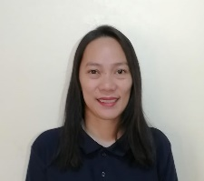

Lorenza Nambayan Santiago

Lorein0723@gmail.com

09177373839 / 85182047

## Objective

To obtain a Customer Service position, where I can leverage my interpersonal skills, problem-solving abilities, and passion for delivering excellent customer experiences. Eager to be a part of be a vital part of company's success.

## EDUCATION

BS Psychology (undergraduate) from 2000-2004

Emilio Aguinaldo College

Paco Manila, Metro Manila

## WORK EXPERIENCE

#### **Sitel Phils**

#### **Customer Service Representative**

August 2006 – May 2007

Answer queries about their billing, maintaining records by updating account information and recommending potential products and services to suit customers’ needs.

#### **Telus International Phils**

#### **Customer Service Representative**

September 2007 – February 2012

Assist customers with their queries like account balance, transaction history and direct deposit. Maintaining records by updating their account information.

#### **Mission Square Chiropractic**

#### **Patient Account Representative**

February 2012 – March 2021

Collect demographic info, verify insurance coverage, prepare and submit insurance claims to a third-party payers and private insurance, follow up on unpaid claims as necessary and assist patients with questions related to their medical bill and insurance coverage.

#### **Ttec**

#### **Customer Service Representative**

January 2021 -November 2021

Answer queries about their billing, recommending best mobile plan and maintaining records by updating their account information.

#### **TPG Telecom**

#### **Customer Service Representative**

November 2021 -Present

Monitor and respond to customer queries and issues through various offline channels such as email and JIRA ticketing systems, investigate and troubleshoot issues related to mobile technical issue and porting numbers between service providers.