Mary Jhoanne Go-oko Dioquino 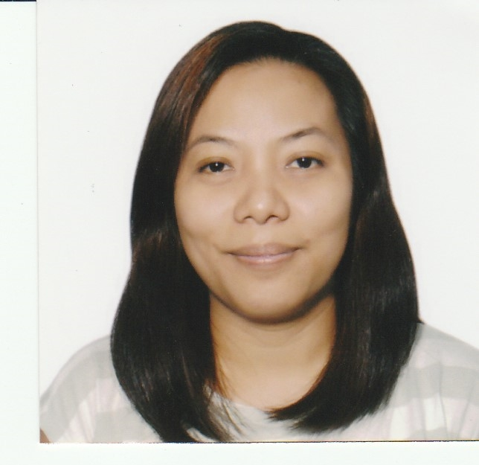
3A Nehemiah St., Camella Homes Classic, Pilar Village, Las Pinas
jhoannedioquino@gmail.com / 63927 136 0832

Functional Summary

Has extensive background in the BPO industry handling various accounts and functions in the field of Customer Service and Data Management. Offers solid leadership experience in Customer Service.

Professional Skills

- Leadership Skills  able to effectively handle a team to achieve common goals with passion for quality and ownership in accomplishing challenging tasks. Excellent people management skills  able to effectively coach and mentor team members.
- Strong thinking and problem solving skills  able to analyze complex escalated calls and problems then provide appropriate solutions that will benefit both the customer and the company.
- Strong interpersonal skills – Ability to work as part of a team and able to deal with diverse group of individuals at all levels of the organization.
- Strong oral and written communication skills  confident and able to communicate and influence people at all levels. Able to provide feedback and make suggestions to clients to better enhance procedures and policies.
- Highly analytical and detail oriented.
- Excellent at priority setting, time management skills and deadline management. Ability to maintain composure under pressure.
- Self-motivated and career driven.
- Has superb ability to respond to changing and dynamic environment.
- Willing to learn applications necessary to do the job function effectively. A fast learner.

Technical Skills

- Proficient in computer application like MS Word, MS Excel, MS PowerPoint, Adobe
- Knowledgeable in using Zendesk.

Employment History
Company Name: Cognizant Technology Solutions
Position: Senior Process Executive
December 2019  present

Job Description:

- Provides help to users of a leading video sharing site using a social media platform.
- Escalates inquiries of users that needs to be handled by back-end support.

Accomplishment:

- Is a consistent performer and belongs in the Top 10% bracket.

Company Name: Alorica
Position: Technical Support Representative/Subject Matter Expert August 2018  December 2019

Job Description:

- Provides technical support for the companys clients handling washers and dishwasher units.
- Sets up schedule for customers who need service for their unit.
- Helps the Team lead in handling the team by collating stats, providing reports and acting as POC when Team Lead is on leave.
- Provides assistance to trainees by providing help in product knowledge and answering their queries regarding processes.

Company Name: Choxi.com/nomorerack.com
Position: Team Leader September 2013  August 2016
Customer Service Representative December 2012  September 2013
Reason for leaving: The company was restructured

Job Description:

- Handles a team to make sure each member delivers quality customer service and hits the required metrics by the company.
- Take escalated calls and make sure that the issue was resolved within company guidelines.
- Does call monitoring and provides coaching to enhance call quality.
- Provide team members their statistics in a timely manner.
- Handles overflow of email inquiries if theres a need.
- Follow-up with suppliers on the status of pending/late deliveries.
- Provide feedback from both employees and customers to management regarding processes that may be beneficial for the company.
- Reports to higher management on team member performance, issues and others.

Accomplishments:

- In less than one year was promoted to Team Leader due to consistent and high QA scores and great product knowledge.
- Was able to keep attrition rate at a minimum. Was always giving one on one coaching to check if any of the team members has immediate concerns that need to be addressed. Only one team member was terminated and no resignations.
- Two deserving team members were promoted by pushing them to apply whenever an internal job posting is rolled out. Gave recommendations to management and provided team members performance score to support the recommendation.

Company Name: Genpact Philippines
Position: Special Services Group April 2012  December 2012
Tier 2 Specialist March 2012  April 2012
Process Associate December 2009  March 2012
Reason for leaving: Preferred a work from home job to concentrate on raising my kid.

Job Description:

- Handles dispute resolution. Checks account first if it qualifies for dispute. Creates the dispute in behalf of the customer. Provide customers the status regarding their billing disputes, make follow-ups if necessary and close dispute if applicable.
- Provides customer service to more complex issues like missing credits, disputes and others.
- Speak with merchants regarding charge not going through and providing information or resolution.
- Check reload cards and submit inquiries to another department if activities look suspicious.

Accomplishments:

- Able to provide resolution on more complex issues to customers resulting to customer retention and more business for the client.
- Consistent and a strong performer  exceeds the metrics provided by clients on a monthly basis.
- Was assigned to higher tier level of customer service.

Other Employments:

Company Name: 24/7 Customer Philippines, Inc.
Position: Customer Service Associate (Australian Account) June 2007  December 2009

Company Name: IBM Daksh Business Processes
Position: Customer Service Associate February 2005  June 2007

Company Name: Customer Contact Center
Position: Quality Assurance Specialist September 2003  November 2003
Customer Service Specialist June 2002  September 2003

Job Description:
- Provide quality customer service and one-call resolution.
- Meet metrics provided by clients.
- Handles billing and product inquiries.
- Handles minor troubleshooting

- Suggests other products to customers that might be helpful to their needs
- Does call monitoring  makes sure that agents follow the correct process in call handling.
- Provide coaching opportunities and commendations.

Accomplishments:
- Able to gain good product knowledge for accounts assigned to in a short span of time..
- Able to adjust to a very dynamic and diverse environment.
- Was promoted to Quality Analyst on my first job in the BPO industry in less than two years.
- Enhanced great my communication and interpersonal skills.

Educational Background:

1998  2002 Miriam College
B.S.B.A. Major in E-Business

1994  1998 Immaculate Conception Parish High School

1985  1994 Immaculate Conception Parish School

Organizational Affiliations:

1999  2002 Inter-School Business Association
1998  2002 Sanggunian ng mga Mag-aaral ng Miriam
1995  1996 Volunteer Catechists Group

Exam/s Taken:
87.5% Civil Service Sub-Professional Career Exam

