**NERIZA D. VILLAREAL**

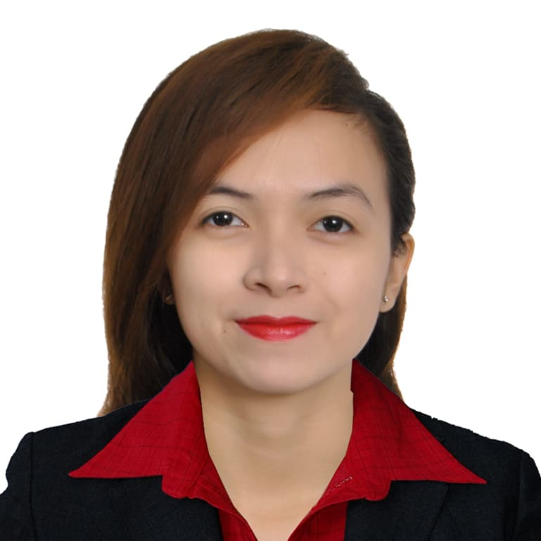

Quezon City, Manila Philippines

Contact Number: 09635418055 / 09669761616

Email Address: villarealneri@yahoo.com

OBJECTIVE

Eager to impart my skills, expertise, creative thinking, and years of experience to make significant contributions to the organization.

EDUCATIONAL BACKGROUND

Tertiary: Bachelor in Secondary Education Major in English

Polytechnic University of the Philippines

SKILLS

* Good Communication and Customer Service Skills
* Problem Solving / Multitasking / Detail-Oriented / Adaptability / Time Management
* Computer Literate (can navigate MS Word, MS Excel, MS PowerPoint, Movie Maker, Internet)
* Typing Speed – 50-60 wpm

SEMINARS/TRAININGS ATTENDED

* Practice Teaching at San Juan National High school

November 2014 - April 2015

* Teacher Education Research Forum

Polytechnic University of the Philippines-Manila

February 14, 2013

* Becoming a Good Speaker

Polytechnic University of the Philippines-San Juan Campus

February 14, 2015

EMPLOYMENT RECORD

* Alorica  
  Quezon City, Centris  
  **Chat Support**

May 25, 2021- October 12, 2022

* Continuum Global Solutions

Ortigas City

**Customer Service** **Representative - Voice**

November 2020 – May 2021

* 24/7 ai Customer Philippines, Inc.

Meralco Ave.,Ortigas Center

**Customer Service** **Representative - Voice**

July - December 2019 / June – November 2020

* Lazada E-Services

Makati, Philippines

**Data Encoder / Quality Control Specialist**

August 2015 - October 2016

CHARACTER REFERENCES

Prof. Leo Cantillang Mrs. Ana Madonna Arellano  
**Professor Guidance Counselor**

**Polytechnic University of the Philippines Polytechnic University of the Philippines**09052171381 09328451110

Prof. Richard Wenbrenner Dacalos Ms. Cindy Saberola

**Professor Manager (Kawara Company)**

**Polytechnic University of the Philippines Aurora Boulevard Quezon City**

09998819810 09213176472