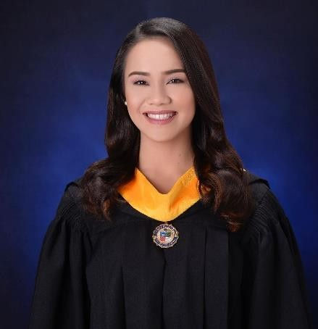**Nowaier G. Barcelona**

Address: Purok 8, Brgy. 39-D, Quimpo Blvd., Davao City

Contact No.: (+63) 908 134 5362

Email: [ngbrcln@gmail.com](mailto:ngbrcln@gmail.com)

**EDUCATIONAL ATTAINMENT**

**Primary :** Philippine Nikkei – Jin Kai International School

**Secondary :** Ateneo de Davao University – High School

**Tertiary :** Ateneo de Davao University

Bachelor of Science in Human Resource Management – 2019

**ACHIEVEMENTS**

**March 2018 Civil Service Exam Passer – Professional Level**

Date of Examination: March 18, 2018

**ON THE JOB TRAINING**

**• Next BPO Solutions**

ACC Building, Quimpo Boulevard, Talomo, Davao City

June 11, 2018 – September 7, 2018

**• Commission on Elections**

Magsaysay Park, Ramon Magsaysay Avenue, Davao City

November 5, 2018 – February 15, 2019

**TOOLS USED / SKILLS**

**• Go High Level**

**• Social Bee**

**• Canva**

**• Basecamp**

**• Castanet**

**• Microsoft Office (Word, Excel, Outlook)**

**WORK EXPERIENCES *(Recent to Past)***

**• Freelance Virtual Assistant** – LinkedIn Account

October 25, 2022 – August 16, 2023

Job Description and Key Responsibilities

As a freelance virtual assistant, I specialize in providing remote support to clients by managing a range of tasks, from content creation and social media campaigns to email correspondence and lead generation on LinkedIn. My expertise lies in enhancing online presence and productivity for businesses and professionals.

As a content creator, I develop and execute content strategies aligned with clients’ goals and target audiences by creating engaging and relevant content for various platforms, including blogs and social media by designing and producing graphic images and videos that complement the content.

I manage my clients’ social media accounts by planning, scheduling, and posting content to increase brand visibility and engagement. I engage with his LinkedIn connections by responding through comments and liking post/s.

I do lead generation with my client’s LinkedIn account by enhancing his profile connections by attracting potential leads and identifying and connecting with relevant industry professionals and potential clients. I initiate and maintain conversation, nurturing relationships to generate leads and referrals.

**• City Health Office – Davao City** – Data Encoder

August 3, 2020 – February 2, 2022

Job Description and Key Responsibilities

My key responsibilities in this role are maintaining the accurate and organized records of our health facility. My responsibilities primarily revolve around data encoding, specifically recording patient information in the E-Konsulta application. Additionally, I am responsible for processing newborns' birth certificates, patients’ PhiHealth claims, and various important office documents.

As a data encoder, I accurately record and update patients’ personal and medical information in the E-Konsulta application, ensuring data integrity and confidentiality. I organize and maintain electronic and physical records of patient data for easy access and retrieval when needed.

Moreover, I verify patients’ PhilHealth eligibility and entitlement to claims coverage, ensuring compliance with PhilHealth policies and guidelines. I prepare and submit necessary documents, monitor the status of claims, follow up on pending claims, and communicate with relevant parties to expedite processing.

When it comes to office documents, I help assist with administrative tasks including but not limited to photocopying, scanning, and printing important office documents. I maintain an organized filing system for office documents both digital and physical, facilitating quick retrieval. In addition to office documents, I create and process birth certificates for newborns, ensuring accuracy and compliance with legal requirements and regulations.

• **RA Hao Group of Companies** – Lease Officer (Accounting Office)

October 2019 – February 2020

Job Description and Key Responsibilities

My key responsibilities are to maintain accurate financial records, ensuring lessee compliance and complaints, and foster positive relationships with lessees. In this role, I accurately calculate rents, electricity, and water bills based on the terms of lease agreements and applicable regulations. I prepare and send statements of accounts to lessees, detailing their financial obligations, due dates, and any outstanding balances. I respond to billing inquiries and payment processing and I regularly reconcile lessee accounts to identify discrepancies and take appropriate corrective actions.

In terms of lease contract management, I maintain and update lease contracts to reflect any changes or modifications, such as rent adjustments, lease renewals, or lease terminations. I ensure lease agreements comply with applicable laws, regulations, and company standards and maintain organized and up-to-date records of contracts and other related documents.

• **Eternal Wallet PH Holdings Inc.** – Senior Marketing Associate

June 6, 2016 – June 8, 2019

Job Description and Key Responsibilities

As a Training and Development Specialist focusing on marketing campaigns, I excel in empowering and nurturing agents' growth while also taking charge of marketing tasks to drive organizational success.

In training and Development, I developed and implemented comprehensive training programs, enhancing the skills and knowledge of agents to improve performance and productivity. I facilitate by conducting engaging training sessions and workshops, individual coaching, and progress monitoring.

In my marketing task/s, I am in charge of strategic planning by collaborating with the marketing team to develop and execute marketing strategies aligned with organizational goals. Contributing to the creation of marketing collateral including but not limited to brochures, presentations, and promotional materials. Do market research by conducting in-depth market research and analysis to identify opportunities and threats. I spearheaded and managed marketing campaigns that played a vital role in launching successful events.

**TRAININGS AND SEMINARS ATTENDED**

• Anti – Money Laundering Seminar

Banko Sentral ng Pilipinas, Davao City

October 3, 2017

• Training and Development: Empowering people, Empowering You

Multipurpose Room, Community Center, Ateneo de Davao University

March 2, 2018

• Pulong – Tulong sa Kaunlaran: Livelihood and Budgeting

Barangay Rosario, Sasa, Davao City

March 3, 2018

• TRAIN Law and its impact to the HR Industry

Conference Room D & E, Ricci Hall, 3/F

September 5, 2018

• Strikes, Lockouts, and Picketing – CBA Negotiations

Room D401 & D403

October 1, 2018

• Labor Relations: An HR Perspective

Room J301

October 13, 2018

• Gender Awareness and Development

Room F213

July 26, 2019