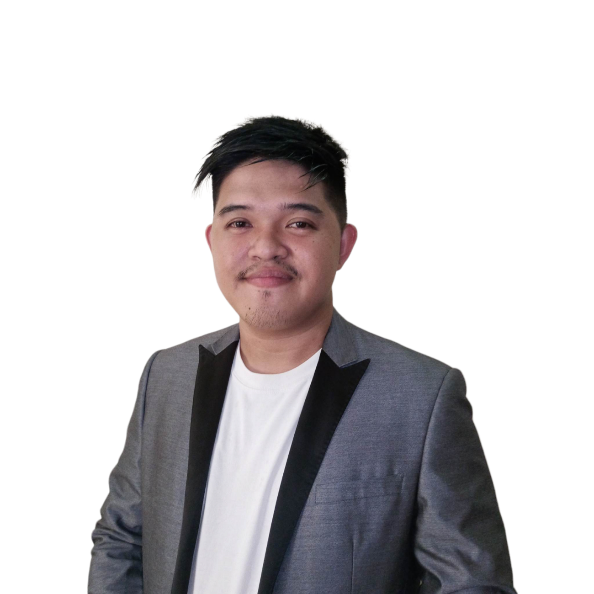

**OWENJEY SAGARIO**

CUSTOMER SERVICE REPRESENTATIVE

+639632384047

owenjey1999@gmail.com

**Ozamiz City, Misamis Occidental**

**PROFESSIONAL SUMMARY**

*As a proactive and self-driven professional, I have accumulated over three years of experience providing excellent client and customer services in the Western region. I specialize in delivering thorough communication to efficiently meet and exceed company goals. My approach is focused on achieving results and finding solutions, consistently aiming to surpass company standards.*

**ACADEMIC BACKGROUND**

**UNIVERSITY OF NORTHWESTERN MINDANAO**

B.S. FOOD TECHNOLOGY

2018-2022

**FMC MA HIGH SCHOOL**

HIGH SCHOOL

2011-2015



**CAREER HISTORY**

**CUSTOMER SERVICE REPRESENTATIVE**TELEPERFORMANCE CDO  
  
Account: Telecommunication Account (T-Mobile)

·Field inbound calls and exhibit the correct sales and customer experience behaviors throughout the entire interaction

·Take a consultative approach to uncovering needs and forming solutions of new products and services that will help businesses succeed.

·Offer solution within the scope of solution to resolve problem easily direction for third party resolution or consultation regarding a paid solution, as appropriate

·Troubleshoot client products as needed to resolve each call the first time

·Meet metrics such as First Call Resolution, Conversion Rates, Net Promoter Score, and New Sales

·Demonstrate extraordinary interpersonal skills and the ability to thrive, multi-task, and prioritize in a high-volume, dynamic

environment

**CUSTOMER SERVICE REPRESENTATIVE**TELEPERFORMANCE CDO 2023-2024

Account: Educational Account (MHE)

· We take care of registration for student who are studying online and also working student.   
· Receive inbound call.  
· Receive technical support for error code.

**TECHNICAL SERVICE REPRESENTATIVE**TELEPERFORMANCE CDO

Account: Telecommunication Account (T-Mobile)

· Field Inbound and outbound calls  
· Advance Troubleshooting

· Sales and billing  
· Order process and cancelation  
· Device to troubleshooting

Phone

Signal service  
 Tablets

Wi-Fi

Watches  
 SyncUP Drive  
 Hotspot

**BASIC TECHNICAL SERVICE REPRESENTATIVE**

SPEAKIFY CENTER INCORPORATED

Account: Telecommunication Account (ATT)

· Field In-bound and outbound calls  
· Advance Troubleshooting

· Sales and billing  
· Order process and cancelation  
· Device to troubleshooting  
· Account inquiry information and cancelation

**INTAKE SPECIALIST/ APPOINTMENT SETTER**

SPLACE BPO  
  
Account: Willens Injury Law Offices

·Responsibility is to make sure that all information is correct and I must have full details and proper documentation on what happened to the call. I must communicate clearly and effectively with clients, ensuring they are fully informed on their options and case progress. Maintain a comprehensive and organized database of client-related information. Monitor and track all new client referrals and ensure accurate records are kept.

**SOCIAL MEDIA MANAGER** 2021-2022

Freelance

·In charge of content creation and publication across various social media platforms, such as Facebook, Twitter, Instagram, and LinkedIn.

· Responsibilities also encompass audience growth, brand  
 exposure enhancement, and revenue generation.

·Tasks include editing photos and videos for content creation, conducting manual outreach to potential clients via LinkedIn filters, and performing copywriting, graphic design, and video editing. Developed a highly successful marketing approach resulting in 5-15 sales calls per week for clients.

Implemented personalized strategies aligned with clients' offers, branding, and target market through LinkedIn, email, and content initiatives.

·Conducted thorough prospect profiling and pre-qualification for qualified and warm leads.

·Proficient in delivering comprehensive virtual assistant services, including administrative tasks, data entry, scheduling, email

management, and document preparation.

·Skilled in internet research, social media account management, and digital file organization. Known for maintaining

confidentiality, prioritizing tasks, and consistently delivering high- quality results within deadlines.

**SKILLS**

Cooking  
Sound Mixing

Music Teaching  
Plumbing

**TOOLS REFERENCE**

Zoom  
Microsoft Teams

Slack  
Outlook  
Excel  
Google Workspace

Microsoft Apps

Photoshop  
Canva  
CRM

**WEBSITE LINK**

FACEBOOK: https://www.facebook.com/owenjey.sagario.2024?mibextid=ZbWKwL

LINKID: www.linkedin.com/in/owenjey-sagario-149054269?utm_source=share&utm_campaign=share_via&utm_content=profile&utm_medium=android_app

**REFERENCE**Enmarie Bagayo  
09948142493  
[bagayoenmarie@gmail.com](mailto:bagayoenmarie@gmail.com)

Mhelnard Balanay  
09189101168  
[mhelnardb@gmail.com](mailto:mhelnardb@gmail.com)

Mitchell Lou Daamo

09532602124  
[daamom@gmail.com](mailto:daamom@gmail.com)