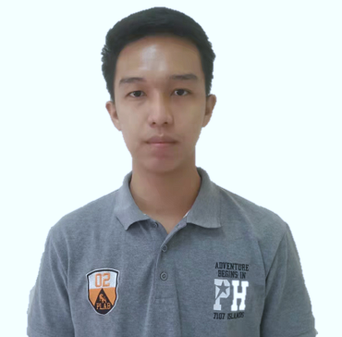 |  | EDUCATION
Tertiary: Mabalacat City College
Year: S.Y. 2013 - 2015
(Dolores, Mabalacat City, Pampanga)
Associate in Computer Technology

Secondary: Dapdap High School
Year: S.Y. 2009 – 2013
(Dapdap, Bamban, Tarlac)

Primary: Dapdap Resettlement Elementary School
Year: S.Y. 2003 – 2009
(Dapdap, Bamban, Tarlac)

RODRIGUEZA, VINCE DARL P.  objective:  To apply and show my skills to the company that will surely benefit both, company and me. Building a good relation as a team.  PERSONAL INFORMATION:  Date of Birth: December 26, 1996  Place of Birth: Quezon City  Age: 26 years old  Height: 6’1’’  Weight: 70 kg.  Gender: Male  Citizenship: Filipino  Civil Status: Single  Religion: Iglesia Ni Cristo  CONTACT  PHONE:  0950-286-8640  ADDRESS:  Blk. 61 Lot 67 Brgy. San Roque, Dapdap, Bamban, Tarlac  EMAIL:  vincedarl.rodrigueza@gmail.com |  | Skills and qualifications
- The Equalizer - School Publish Paper (Cartoonist) Mabalacat City College
- Self-motivated and hard working with good interpersonal skills.
- Average Encoder using Microsoft Office
- Microsoft Office Literature (Word, Excel, PowerPoint)
- Ability to work on a team
- Auditing Skills
- Documentation

 |  | seminars and trainings
IT GATEWAYS
PSITE (SAITE 2013)
Olongapo City Convention Center, Olongapo City

ICT EDUCATION: YOUR PASSPORT TO GLOBAL SUCCESS
PSITE (SAITE 2014)
Lou-is Resort and Restaurant, Balanga City, Bataan

 |  | WORK EXPERIENCE
Position: Customer Service Clerk
Company: MERCANTILE STORE INC.
SM CITY CLARK
Duration: November 2015 – April 2016

Position: Production Operator
Company: MOLEX PHIL.
Duration: May 2016 – September 2017

Position: Plotter
Company: MEDIA TRACK SEA INC.
Duration: September 2017 – April 2018

Position: Office Staff (Dept. Supervisor)
Company: STELLA PHILIPPINES
CORONATION PREMIUM MANUFACTURING INC (CPMI)
Duration: May 2018 up to Present

PROFESSIONAL EXPERIENCE
Office Staff – Business Dept.:
• Preparing & purchasing all the materials for Tech Shoes and new style Shoes.
• Creating BOM (bills of materials) for new patterns & new styles of shoes.
• Updating BOM such as usage, new material description and improving or changing of materials to improve the Finish Mass Production shoes and making sure the BOM is accurate and updated.
• Sending information needed by China Team & Brand about Tech Status and assisting VF & DECKERS Guest during their audit.
• Answering emails from supplier, colleagues from other factories of STELLA, VF Corporation & DECKERS BRAND.

FKR – Factory Key Representative:
• Execute Quality Audit on behalf of VF.
• Ensure the shipped products conform to VF brand requirements and Quality Audits are performed on timely basis.
• Provide feedback to VF Quality Auditor/ Production Operation Manager.

References:
PETER PAUL TORRES MARY JOY ALBANEZ
DEPARTMENT SUPERVISOR WAREHOUSE SUPERVISOR
CORONATION PREMIUM MFG INC CORONATION PREMIUM MFG INC
Contact # 0910-466-3139 Contact # 0908-971-9374

I hereby certify that the above mentioned about me is true and correct to the best of my knowledge and ability.

VINCE DARL P. RODRIGUEZA
Applicant

