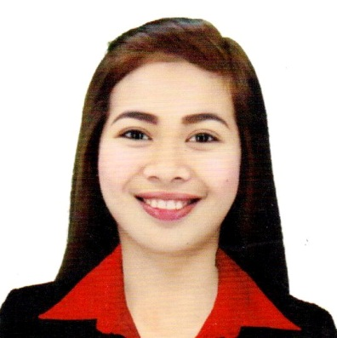
Zaira R. Pagcaliwangan
Sico, Lipa City
09352006861
pagcaliwanganzaira.13@gmail.com

CAREER OBJECTIVE:

SKILLS AND ABILITIES:

EDUCATION

SEMINARS ATTENDED

“Bridging the Gap”
Sen. Diokno Auditorium, De lasalle Lipa, Lipa City Batangas
September 22, 2019

“First Nation Building Summit”
Teresa Yuchengco Auditorium, Dela Salle University
November19, 2019

WORK EXPERIENCE
November 2016-2018
Mcdonald’s Tambo- Crew Member
Achievement:
Awarded “Crew of the month”
“Best of the Best” in Service
Regularly exceeded Sales Target
Promoted as Local Store Marketing

August 2021- February 2022
Toyota Lipa Batangas
Marketing Staff

August 2022 up to present

ACDI Multipurpose Cooperative
Admin Assistant
August 2022 up to present

To work in an environment where I can fully make use of my skills, efficiency and responsibility, facilitating development of the organization and establish a promising career.

- Adaptable and eager to learn
- Able to build good-working relationships
- Able to manage multiple tasks in pressured environment
- Willing to learn, explore and acquire new things
- Competent and takes initiative

Tertiary Kolehiyo ng Lungsod ng Lipa
Bachelor of Science in Business Administrion Marketing Management
Marawoy Lipa City
2020

Secondary Fernando Airbase National Highschool
Fernando Airbase Lipa City 2011

Primary Sico Elementary School
Sico Lipa City
2005

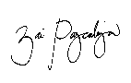
I hereby certify that the above information are true and correct to the best of my knowledge and belief.

ZAIRA PAGCALIWANGAN
Applicant

