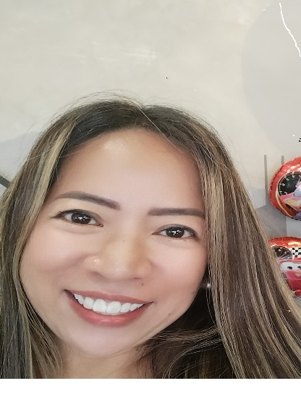

**MARIA CARLOTA CAMPOMANES DIZON**

223 C. Dizon Ave. San Joaquin Sta. Ana Pampanga

+639182020368

lotizkhi@yahoo.com

**SUMMARY**

Resourceful, flexible Customer Service/Operations Professional with over 11 years of successful experience in a USA Telecom account requiring high levels of precision. Adaptable, transition easily between small and large tasks. Personable individual who enjoys working with customers and colleagues from all different levels of profession.

**SKILLS**

Customer Service Management and Sales, Excellent in oral and written Communication Skills and Telephone manner, Experience in measuring employee performance including coaching to call center metrics, Strong Technical Skills (MS Windows, keyboarding, strong systems aptitude), Focused and productive with less supervision

**WORK EXPERIENCE**

**Teletech – Team Leader (Chat Support) (Telco Account)**

March 2021 – June 2022

Assure team is in accordance with the policies and procedures and hold accountability for meeting all performance indicators and metrics using reporting tools and techniques; answers’ associate/expert questions, issues, and customer escalation while ensuring quality customer experience on every chat; provide motivation and full support to meet and exceed expectations in attaining monthly goals; coach and lead associates to ensure achievement of company and client quality goals while addressing employee related issues, coordinating training on new or revised information relating to products and various processes; provide time management and organizational skills to manage multiple, complex, on-going tasks and projects while monitoring absence and attendance of the team

**Teletech – Messaging/Chat Expert (Telco Account)**

July 2020 – March 2021

Handling customer queries on web chat; educate current and potential customers with product and service information; maintain accurate customers’ records; identify and escalate priority issues to the Team Leader; provide basic trouble shooting for customer’s having issues with their phones; provide right fitting to customers regarding their current plan to a much better and suitable plan; advise customer of new products/offers after resolving their concerns/issues which will lead to potential sales; provide save attempt for customer’s wishing to terminate/close their account

**Teletech – Customer Service Representative II (Inbound CSR/Telco Account)**

September 2014 – June 2020

Receives incoming calls from past, existing and potential customers and address their issues and inquiries; manage and resolve customer complaints; sell products/offers and assist in placing orders once customer agrees to the offer; identify and escalate issues to Team Leader; assist customers on managing their accounts and right fit to the correct plan; provides benefit of staying in the company for customer’s wishing to close their account; assist customer in porting their previous phone number

**Teletech – Customer Service Representative I (Inbound CSR/Telco Account)**

March 2011 – May 2014

Receives incoming calls from past, existing and potential customers and address their issues and inquiries; manage and resolve customer complaints; sell products/offers and assist in placing orders once customer agrees to the offer; identify and escalate issues to Team Leader; assist customers on managing their accounts and right fit to the correct plan; provides benefit of staying in the company for customer’s wishing to close their account; assist customer in porting their previous phone number

**Fujitsu Computer Products Corp. of the Philippines - Quality Control Engineer**

May 1997 – June 2001

Conducts ISO 9001 and 14000 audit for the company; maintain and revised all company work manuals and ensure production adheres by conducting quality audit on a daily basis; provide audit reports to higher management; conduct meetings to all production leaders and operators; provide trainings to newly promoted leaders and new hires

**EDUCATION**

**Certificate in Business Administration**

Computek Institute of Technology

Ontario, Canada

September 2003 – March 2004

**Bachelor of Science in Industrial Engineering**

Mapua Institute of Technology

Intramuros, Manila

June 1993 – April 1997